CENWP-OD 10 August 2020

MEMORANDUM FOR THE RECORD

**TITLE** - 20DET02 MFR Elevated TDG

**PROJECT** - Detroit Dam (North Santiam River)

**RESPONSE DATE** - 24 August 2020

**Description of the problem**

Detroit Dam Temperature Management operation: On June 18 and 19, 2020, the proportion of spill at Detroit Dam increased above 60% elevating total dissolved gas levels (TDG ~118%) below Big Cliff Dam. The increase in Detroit spill was caused by the combination of an increase in total outflow to maintain Detroit pool elevation at or below rule curve and a "no-load spill" request from BPA.

Big Cliff Dam unit maintenance: Further, on July 20, 2020, the unit at Big Cliff Dam was taken offline for annual maintenance resulting in elevated total dissolved gas (TDG).

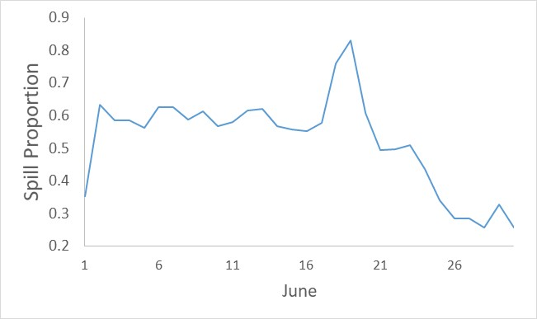

Figure 1. The proportion of discharge as spill in June 2020 at Detroit Dam based on daily averages.

**Type of outage/event**

* Detroit Dam Temperature Management operation: On June 18 and 19, 2020, the proportion of spill at Detroit Dam increased above 60% elevating TDG (TDG ~118%) below Big Cliff Dam.
* Big Cliff Dam unit maintenance: Further, on July 20, 2020, the unit at Big Cliff Dam was taken offline for annual maintenance.

**Impact on facility operation**

* Detroit Dam Temperature Management operation: Minimal impacts of TDG (104%) at the Minto Fish Facility were observed.
* Big Cliff Dam unit maintenance: TDG levels of %XXX at the Minto Fish Facility were observed.

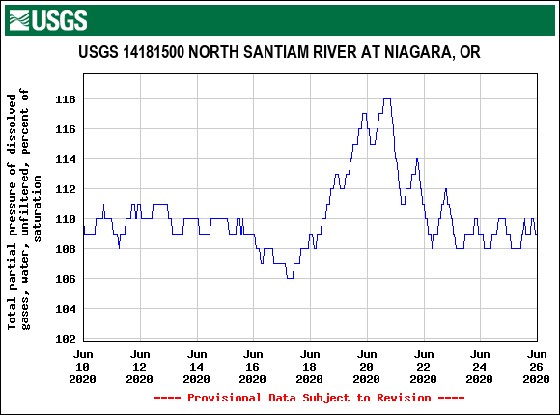

Figure 2. Total dissolved gas levels in mid-June below Big Cliff Dam in the North Santiam River.

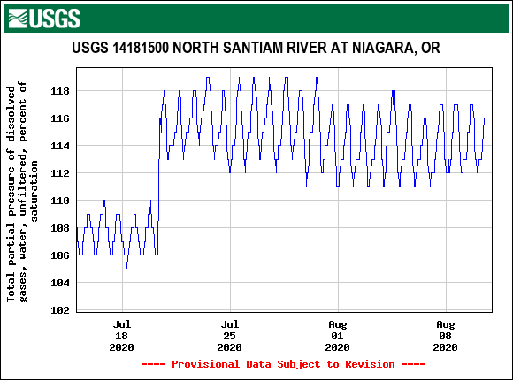

Figure 3. Total dissolved gas levels in below Big Cliff Dam in the North Santiam River (July 15-August 10).

**Dates of impacts/event**

Detroit Dam Temperature Management operation: Impacts of the event were approximately June 18-21 regarding the TDG increase due to increased spill. Note that TDG levels were around 110% before the event due to typical temperature management operations.

Big Cliff Dam unit maintenance: July 20, 2020 - TBD

**Length of time of impact**

Detroit Dam Temperature Management operation: ~ 3 days

Big Cliff Dam unit maintenance: TBD

**Expected impacts on fish**

* Detroit Dam Temperature Management operation: Elevated TDG levels (peaked at 118%) were observed in the reach between Big Cliff Dam and the Minto Fish Facility. Levels of TDG were as high as 104% at the Minto Fish Facility. Elevated TDG levels can cause gas bubble disease and fish mortality. As of June 30, there were 608 non-marked spring Chinook and 220 winter steelhead placed in the reach between Big Cliff Dam and the Minto Fish Facility (barrier dam). In the month of June alone, there were 557 non-marked spring Chinook placed in this reach.
* Big Cliff Dam unit maintenance: As of July 30, there were 1,284 non-marked spring Chinook and 220 winter steelhead placed in the reach between Big Cliff Dam and the Minto Fish Facility (barrier dam).

**Comments from agencies**

Please email or call with questions or concerns.

Thank you,

Chris Walker

NWP Operations Division Fishery Section

503.808.4316

[Christopher.E.Walker@usace.army.mil](mailto:Christopher.E.Walker@usace.army.mil)